**Abstract:**

Tracking your spending is often the first step in getting your finances in order. By understanding what you spend money on and how much you spend, you can see exactly where your cash is going and areas where you can cut back.

It’s easy to make this part of your everyday routine thanks to expense tracker apps that help you manage your money on the go. These apps certainly overlap with [budgeting apps](https://www.cnbc.com/select/best-budgeting-apps/), but while the latter provides a big-picture view of your finances, expense tracker apps put more of an emphasis on your spending. These apps usually categorize your expenses and help you get a good idea of your purchasing behaviour.

Most people know the importance of keeping business receipts in case they’re [audited](https://www.investopedia.com/articles/personal-finance/032415/how-do-irs-audits-work.asp). The problem with paper receipts is that it’s easy to lose such an important document. By immediately uploading these into an expense tracker app, you save space and time instead of having to dig through a shoebox full of receipts come tax time.

Many of these expense tracker apps do more than receipt tracking. You can monitor your credit, send invoices, create a budget, reconcile accounts, track the performance of investments, and create mileage records. Most of these apps are free or very low cost.

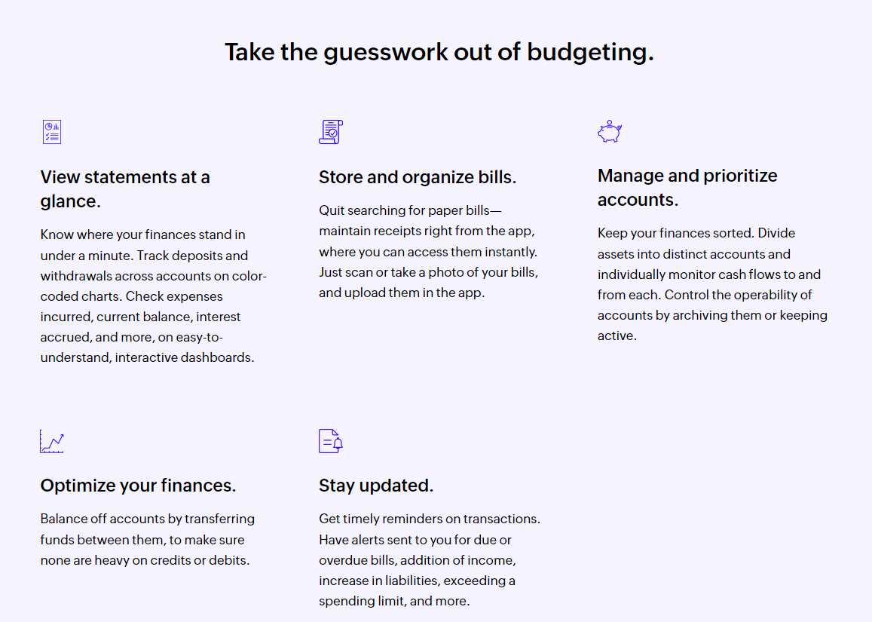 **Related works:**

Managing expenses in everyday life is paramount. With the help of modernization, multiple efforts have been attempted to make the process of tracking and managing one’s finance a simple job. Previous works show the development of android applications which has been incorporated with features like recording personal expenses, investment options, view of stock market, display latest financial news, and many more. [1] Most of the student because of their busy schedule they find it difficult to calculate their expense and income that is the one reason they face money crisis, in this case daily expense tracker can help the student to tracking income-expense day to day and making life tension free and focus easily on their career.[2] Studies were conducted among a group of 14 people and their financial habits and the observations from the experiments were used to draw 3 important factors about how people manage finance: their emotional relationship with finances, the tools used by them to track finances, accountability of unpredicted expenses. [3] Software can keep track of expenses by just scanning copies of bills, by tracking the SMS on the mobile and use these data to maintain a balance of income and expense. [4] Monitoring of client costs, their commitment to the group’s expense and much more was managed by a portable application. [5] We intend to build an application that introduces more features than the mentioned works above and simultaneously address the issues present in them.

There is an aliter approach application implements least squares method which helps to predict an outcome by finding the best fit line for a set of data. The use of the least squares method will help users in obtaining a successful budget planned with the prediction of the outcome of the budget based on expenses[6]. On a weekly, monthly, and yearly basis, details of expenses will be displayed in the form of a pie chart. It aids us in remembering and adding information about what money we receive from others and what costs or payments we must make on a given date or month.[7]. We can input from the user an income, source of this income and the date of earning that income and creates a transaction entry under income category sums to the total amount of income and making real time changes. The web application can also be voice powered and all the functionalities can be used with voice commands.[8].

Expense via a graphical representation. We can also add a special feature which will distribute your expenses in different categories suitable for the user. An expense history will also be provided in application [9]. The development of this application has been conducted in a stepwise manner using the well-defined methodology, RUP, customized according to the requirements of the system. Most of the goals set at the start of the development phase have been met. Security problems like web security or network security have also been treated in the design and development of the system, thus increasing the reliability of the system. Quality management issues have also been handled satisfactorily [10].

**References:**

[1] Velmurugan; Richard Francis; *Expense manager application. Dec 2020*

[2] Saumya Dubey; Rigved Rishabh Kumar; *Student expense tracking application. Apr 2014*

[3] Joesph Jofish; Rebecca; *Tracking personal finances Apr 2014*

[4] Shahed Anzarus Sabab; Sadman Saumik Islam, Md. Jewel Rana; Monir Hossian; *e-Expense: A Smart Approach to Track Everyday Expense*

|  |
| --- |
|  |

[5] Yash veer Singh; Dhirendra Yadav; Kunal Singh; *Group expense tracker Jun 2020*

[6] Daily Expense Tracker Mobile Application; Nuura Najati Binti Mustafa

[7] Expenditure management system; Dr.V.Geetha, G. Nikhitha.

[8]. Daily Expense Tracker; Shivam Mehra, Prabhat Parashar

[9]. Expense tracker application; Velmurugan.R ,Mrs.P.Usha

[10]. Intelligent Online Budget Tracker; Girish Bekaroo and Sameer Sunhaloo